***Experiment 5 Lab Report: Qualitative Analysis***

**Author:** Ricci Lam

**Date: 11/19/2016**

**TA Name: Matthew Du**

**ACCURACY (20 points)**

Unknown #: 117

Ions present in unknown: Hg2+, Fe3+, Ni2+

**ABSTRACT (10 points)**

This experiment employed the use of qualitative analysis to determine the presence of different species of transition metals within an unknown sample of a solution with very little volume. This experiment was carried out with the help of the concepts of solubility rules, meaning that the transition metals within the solution were slowly precipitated out with the use of different ligands and anions. First, chloride salts were precipitated out from the solution with the addition of HCl (hydrochloric acid) and HNO3 (Nitric Acid). After, the addition of various salts, bases, and acids to slowly precipitate out the remaining ions in the solution. The sample used in this case is unknown sample #117 and the sample yielded Hg2+, Fe3+, and Ni2+.

**INTRODUCTION (20 points)**

Semimicro qualitative analysis is using a small sample to determine the presence of different ions in an unknown solution. The best way to carry out semi qualitative analysis is to conduct a parallel procedure on a sample of a known solution. The effects of a given procedure on both can be noted and similarities would amount to parallel ions present in both solutions. This method of analysis is used when there is a limited amount of solution for analysis and only the species of the ions need to be confirmed. For example, when scientists need to analyze the content of rock to determine the composition and the presence of certain target transition metals.

In this particular Experiment, an unknown solution will be tested for the presence of different transition metals, namely Ag2+. Hg22+, Mn2+, Fe3+. Cr3+, Ni2+, and Zn2+. An unknown sample was provided for testing and a known sample was tested with it. First, the Chloride salts were precipitated out, with the supernatant containing the rest of the ions being transferred to a separate test tube for later use. Different solutions are added to dissolve and precipitate Mercury ion and Silver ion in turn to confirm their presence. For the non-chloride salts, they are all first oxidized and then made into different compounds and colored polyatomic ions. The ions and salts all have a distinctive color that will show their presence and that distinctive color will be used to confirm their presence in the original unknown solution.

|  |  |
| --- | --- |
| Salt or Compound | Ksp Value |
| AgCl (Silver Chloride) | 1.77 x 10-10 |
| Hg2Cl2 (mercury chloride) | 1.43 x 10-18 |
| Mn(OH)2 (Manganese Hydroxide) | 1.9 x 10-13 |
| Fe(OH)3 (Iron-(III) Hydroxide) | 4 x 10-38 |
| Ni(OH)2 (Nickel Hydroxide) | 5.48 x 10-16 |
| MnO2 (Manganese Oxide) | 1.45 x 10-18 |
| Ni(C4H7N2O2)2 Nickel(II)-dimethylgloxime | Unknown (insoluble) |
| BaCrO4 (Barium Chromate) | 1.77 x 10 -10 |
| Zn3K2[Fe(CN)6]2 (Zinc Ferric Cyanide) | Unknown (insoluble) |

**RESULTS (45 points total = Data + Observation, including visual aids)**

***Data+Observations, including visual aid, for initial separation (preceding Groups A and B)***

Observations for Known

* The known solution was colorless, even though all of the reactions.

Observations for Unknown

* 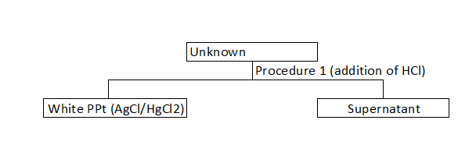The solution was a transparent teal color and the color turned lime green upon addition of HCl

***Data+Observations, including visual aid, for Group A (insoluble chlorides)***

Observations for Known

* Turned Cloudy with the first addition of HCl and did not turn cloudy with the second addition of HCl.
* Supernatant transparent after addition of HCl
* Black/deep gray precipitate formed with the addition of 15 M NH4OH, indicating the presence of Hg2+ The supernatant was clear and colorless
* White precipitate formed when 6M HNO3, indicating the presence of

Observations for Known

* Turned cloudy with the first addition of HCL, did not turn cloudy with the second addition of HCl. The solution did not turn cloudy after the second addition of HCl after being centrifuged
* The supernatant was lime green upon decanting. Small amounts of precipitate, not enough to generate a pellet was accidentally transferred to the new unknown supernatant test tube.
* Black/Deep gray precipitate formed upon the addition of NH4OH. The supernatant turned clear and colorless after the solution with precipitate was centrifuged.
* No additional precipitate formed upon the addition of HNO3 and the pH of the solution was checked, the pH paper indicated “Strongly Acidic”.

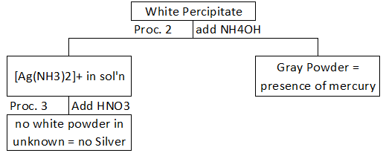

***Data+Observations, including visual aid for Group B (soluble chlorides)***

Observations for Known Solution

* Deep brown sludge formed with the addition of 6M NaOH. The solution is a bright yellow shade. The pH paper used for testing indicated that the solution was strongly basic
* H2O2 addition to the test tube dissolved the sludge in the known
* The processing in the water bath led to some evaporation.
* The known supernatant is a pale green: there was black/deep brown precipitate formed during the processing by bubbling
* The known was processed for MnO4-
* H2SO4 was first accidentally added to the precipitate, it was washed several times. Small amounts of the precipitate were lost with each washing. There was a sizeable amount of precipitate in the test tube upon completion of washing.
* A single large scoop of the NaBiO3 was added to the test tube. Not all of it dissolved upon vigorous mixing.
* After centrifuging the solution, the NaBiO3 was condensed into a pellet at the bottom, leaving a rich purple/magenta color in the liquid, indicating the presence of Mn2+ ion in the known sample
* A deep red was observed when NH4SCN was added to one of the supernatant knowns from the split of supernatant in procedure 6
* For procedure 9, 5 M NH4OH was added until pH test strips indicated that the solution was strongly basic.
* The solution turned bright hot pink with the addition of dimethylgloxime solution. N indicating the presence of Ni2+ in the known solution.
* In Procedure 10, the supernatant from procedure 5 had small amounts of precipitates, so it was centrifuged and decanted into a clean test tube.
* The solution was yellow, and produced a yellow precipitate upon the addition of BaCl2/ after centrifuging the mixture, the solution became colorless and the yellow on the precipitate became more pronounced.
* The supernatant was transferred to a clean test tube
* For procedure 11, 20 drops of HCl added until the supernatant tested for “strongly acidic”.
* Off white precipitate formed when K4Fe(CN)6 was added to the solution. Experment was ended here because there was no precipitate in known, therefore, with the confirmation of no Zn2+ in the solution, there was little point in continuing the experiment.

Observations for Unknown Solution.

* Solution turned a yellow and a rust colored precipitate formed in the unknown with the addition of 6M NaOH
* The addition of H2O2 does not dissolve the precipitate, but the boiling water bath turned the solution into a clear color, while the precipitate became a feces brown.
* Small amounts of the precipitate were lost to cleaning.
* When H2SO4 was added, the precipitate completely dissolved, with no precipitate remaining. The solution was split in half for later procedures, procedure 7 was skipped because there was no precipitate to process and therefore, no Mn2+
* NH4SCN was added to one half of the unknown solution and it turned a deep blood red, confirming the presence of Fe2+
* 5M NH4OH was added to the test tub until the pH paper showed “strongly basic”.
* The solution turned a bright pink when dimethylgloxime was added, confirming the presence of Ni2+
* For the supernatant from procedure 5, when BaCL2 was added, the solution sowed no change, although there were small amounts of rust colored precipitate, meaning that there was some form of impurity in the solution that was not connected with Cr2+.
* HCl (~20 drops) was added until the solution was added until the solution became strongly acidic after transfer to another test tube. The solution turned a shade of pale green, but there was no precipitate formed after 5 minutes of waiting, meaning that there was no presence of Zn2+ The experiment was ended there because the presence of Zinc was disproved.

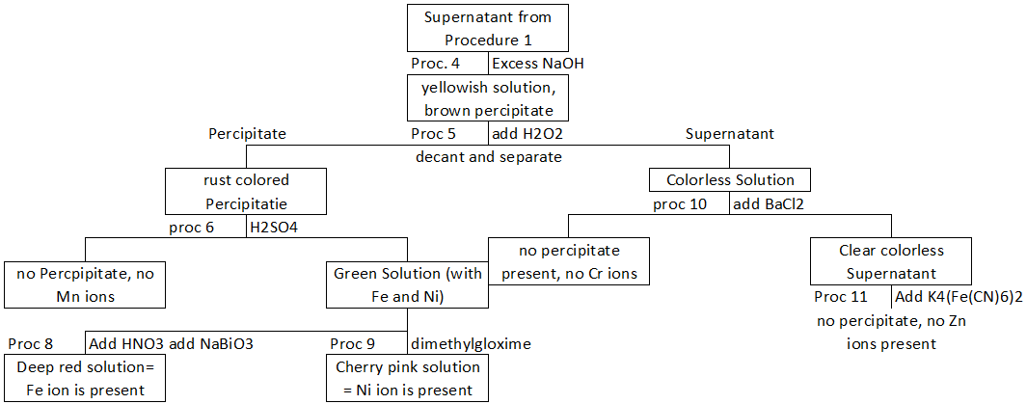

**DISCUSSION (20 points)**

In this experiment, various solutions and chemicals were added to an unknown solution in order to isolate certain target ions, namely transition metal ions. In this experiment in particular, the sample #117 was tested for various transition metals, but only Mercury (Hg2+), Iron (Fe2+), and Nickel (Ni2+) were found to be in the original solution. In certain parts of the experiment, there were places where the solution did not react as predicted in the lab manual.

In the portion where the presence of Chromium was tested, instead of forming BaCrO4, which should have been a yellow precipitate, small amounts of rust colored precipitate formed with the addition of BrCl2 solution, after centrifuging and adding more BrCl2, no more precipitate formed. This sort of anomaly can be explained by the accidental transfer of small amounts of precipitate from one procedure to the next with it dissolving into the solution and then becoming impurities that will show up in later parts of the experiment, as in the example with procedure 11. The opposite problem would also be true with the improper decantation of supernatants from their precipitates. A precipitate would appear to be properly decanted, but in fact, it would sometimes retain some liquid of the original supernatant in the pellet after centrifuging. This leftover supernatant is usually washed away with multiple washes of Deionized water, but even after some washes, a sizeable amount would remain occasionally. In this experiment, the addition of K4[Fe(CN)6]2 Made the unknown a blue color, without producing any precipitate at all. This anomaly generally indicates one or more of three things things: the decanting of the solution before was improper, there are impurities in the solution from earlier parts of the experiments, or that there are impurities in the solution that are not accounted for in the tests made and some of these impurities may have been introduced with the addition of various solutions in previous procedures and were not properly washed out. The most probable error that produced a blue solution is that the chemical impurities were not properly washed out earlier and the accumulated, resulting in a blue solution upon the addition of the Iron cyanide complex into the solution. One other source of error (although not specific to this case) is that small amounts of supernatant left in the pellet after washing would later affect the results of the determination of later ions. These leftover ions my affect the color of the solutions that are needed to determine the presence of specific ions like Nickel.

Semi micro Qualitative analysis is used in real-world tests to determine the presence of certain chemicals in a solution. This is useful in real world tests for the presence of transition metals in ores if a company wanted to find optimal locations to mine for rare or useful metals like tungsten, chromium, nickel, copper, and other transition metals. This procedure would not work on alkali or alkaline earth metals because they are much more difficult to force out of solution and do not readily make many colored solutions when mixed with water, not to mention the fact that they are dangerous to put into water.

**BIBLIOGRAPHY (5 points)**

1. Euler, Bill. "Solubility Product Constants at 25 OC." Solubility Product Constants at 25 OC. Chemistry 112, Web. 21 Nov. 2016.
2. "Solubility Product Constants Ksp at 25°C." Solubility Product Constants Ksp at 25°C. Web. 21 Nov. 2016.
3. Averill, Bruce A., and Patricia Eldredge. "Chapter 26 Appendix B: Solubility-Product Constants (Ksp) for Compounds at 25°C." Appendix B: Solubility-Product Constants (Ksp) for Compounds at 25°C. Creative Commons, 29 Dec. 2012. Web. 21 Nov. 2016.